PRDA – 04 Customer Data Analysis

Task:
- How is the shopping distribution according to gender?
- Which gender did we sell more products to?
- Which gender generated more revenue?
- Distribution of purchase categories relative to other columns?
- How is the shopping distribution according to age?
- Which age cat did we sell more products to?
- Which age cat generated more revenue?
- Distribution of purchase categories relative to other columns?
- Does the payment method have a relation with other columns?
- How is the distribution of the payment method?
- Visualize the data using Tableau /PowerBI and derive insights and give your inputs/suggestions to the company.

About Dataset:
This dataset contains shopping information from 10 different shopping malls between 2021 and 2023. We have gathered data from various age groups and genders to provide a comprehensive view of shopping habits in Istanbul. The dataset includes essential information such as invoice team7categories, quantity, price, order dates, and shopping mall locations.

Database Credentials:
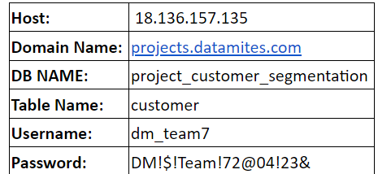

Attribute Information:
invoice_no: A combination of the letter 'I' and a 6-digit integer uniquely assigned to each operation.
customer_id: A combination of the letter 'C' and a 6-digit integer uniquely assigned to each operation.
gender: String variable of the customer's gender.
age: Positive Integer variable of the customers age.
category: String variable of the category of the purchased product.
quantity: The quantities of each product (item) per transaction.
price: Product price per unit in Turkish Liras (TL).
payment_method: String variable of the payment method (cash, credit card or debit card) used for the transaction.
invoice_date: The day when a transaction was generated.
shopping_mall: String variable of the name of the shopping mall where the transaction was made.

Students must submit the following:
Expected Outputs
- Insights narrative in analysis report (comes as .pdf,.doc or .txt)
- Charts (screenshots)
- PPT upload

